**Now see the percentage of the training model:**

**1 means 100%**

**.75 means 75% accuracy.**

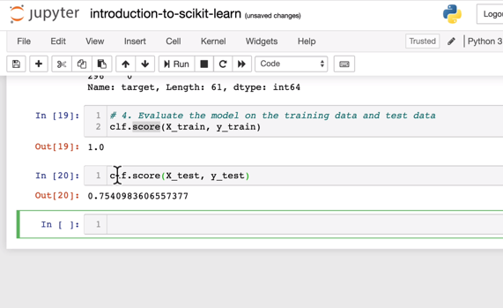

**Let’s import more matrix:**

from sklearn.metrics import classification_report,confusion_matrix,accuracy_score

print(classification_report(y_test,y_preds))

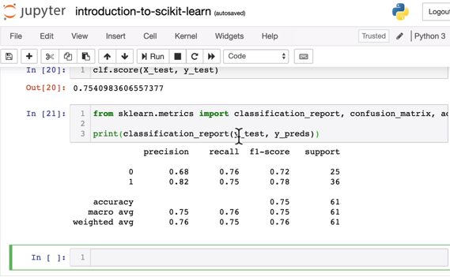

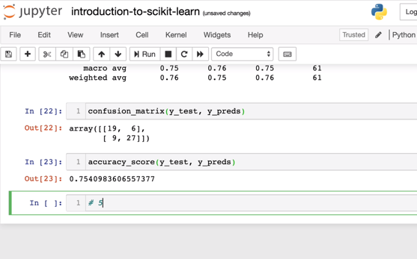

**Now let’s improve the model:**

We are not happy with the accuracy score so let’s improve the model by trying different value for nestimators which is one of the hyper parameter dials on machine learning to improve it.

Now let’s try different nestimators with different values in a for loop

Limit it to 2 decimal spaces like below for test data

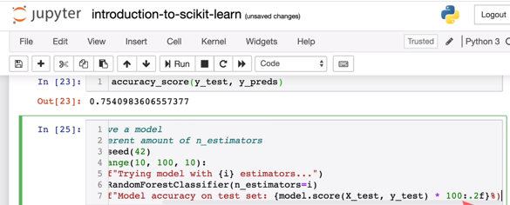

Now the best model has come out when we adjust it to 20 estimators to get 83.61% accuracy

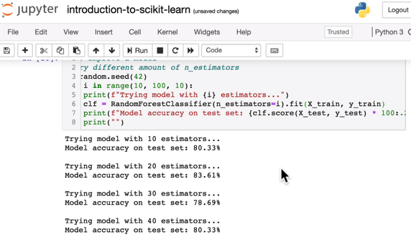

Now save the model using **python pickle** package:

Import pickle package

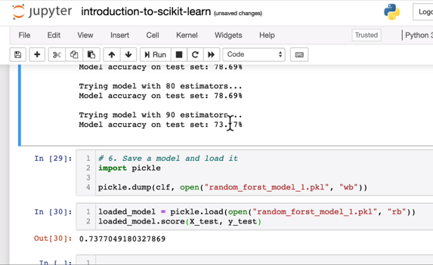

You can ignore warnings by importing warnings package:



To see scikit-learn version, please use below:



**To upgrade a package:**

Example:

Conda update scikit-learn 🡪 command to upgrade the package

List packages:

Conda list scikit-learn

If it doesn’t upgrade then see for the dependencies:

Conda search scikit-learn –info

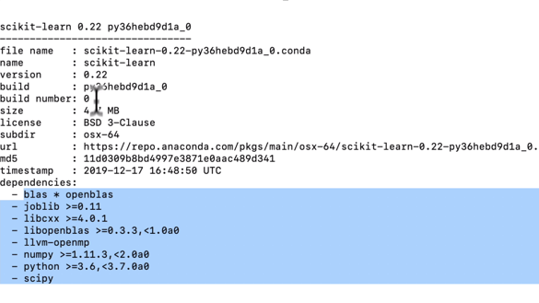

We need to have above dependencies:

So in order to uninstall and install the packages , please use below:

Conda uninstall scikit-learn python

After unsiatlling, pelase install with correct version

Conda install scikit-learn=0.22 python=3.6.9 matplotlib pandas numpy jupyter

**Getting our data ready:**

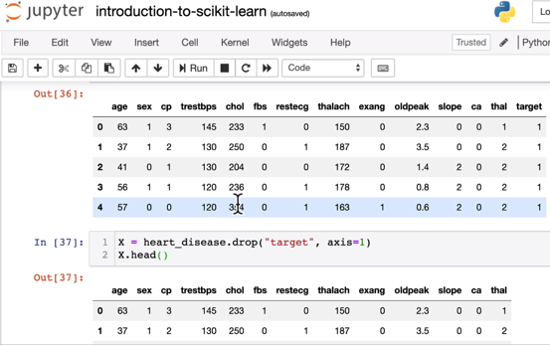

Now split the data into training and test sets:

from sklearn.model_selection import train_test_split

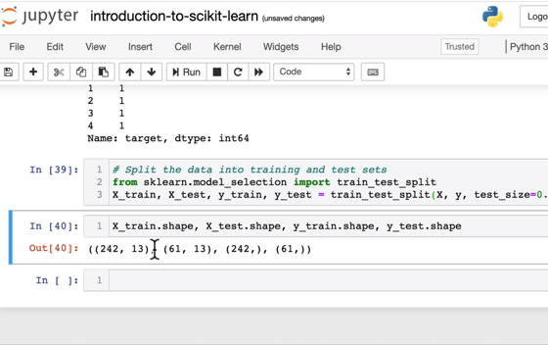

We have split our data as training = 80% and test = 20%

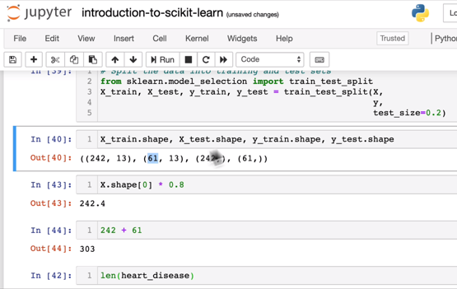

**Cleaning up data or Data cleansing:**

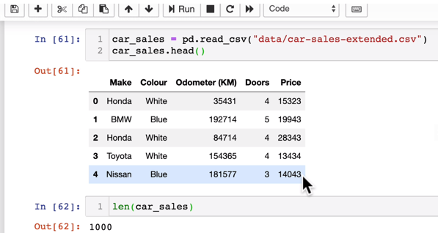

**Convert the categories (strings) to numbers.**

from sklearn.preprocessing import OneHotEncoder

from sklearn.compose import ColumnTransformer

even though doors are numerical, it is a category

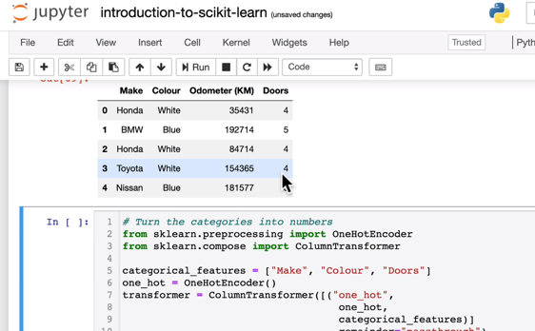

This is spitting out an array , let’s put this in to a data frame to make sure if it makes sense.

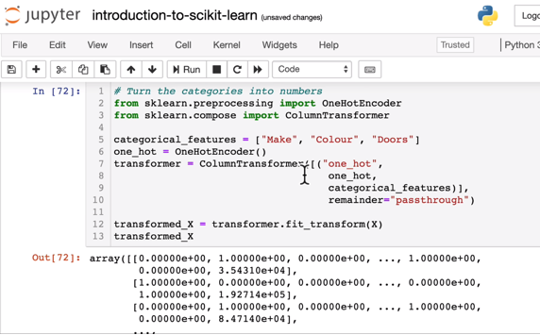

pd.DataFrame(transformed_X)

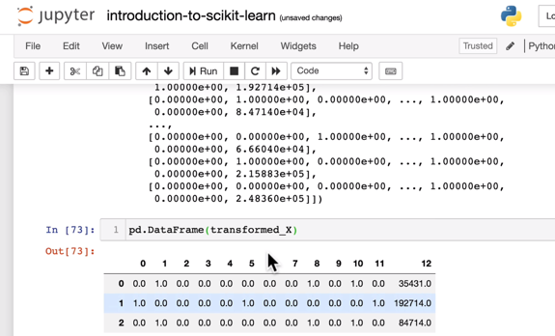

Here we are saying hey columnTransformer() apply oneHotEncoder() to apply on categorical_features and for the remainder of the columns do not do anything and just pass through.

What is oneHotEncoding

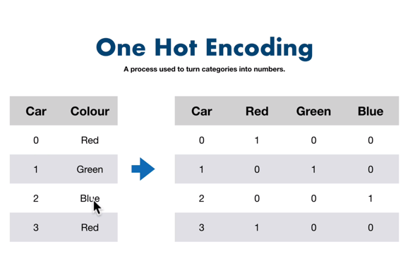

It has converted all strings to numbericals which the machine can understand

**Now there is one more way of doing this using pandas**

dummies =pd.get_dummies(car_sales[[“Make”,”colour”,”Doors”]]

dummies

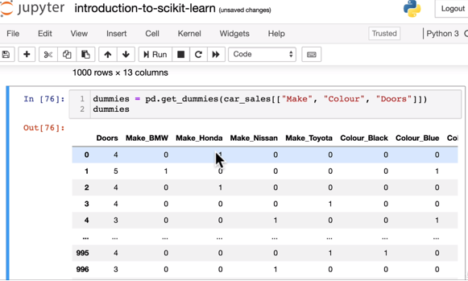

**Let’s refit the model**

np.random.seed(42)

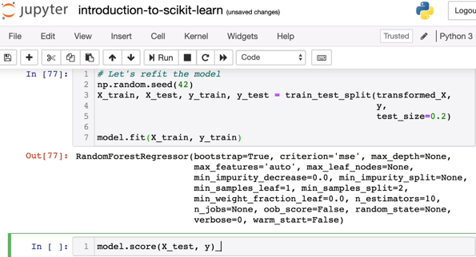

It got a below score of 0.30 ( which is just 30% accuracy)

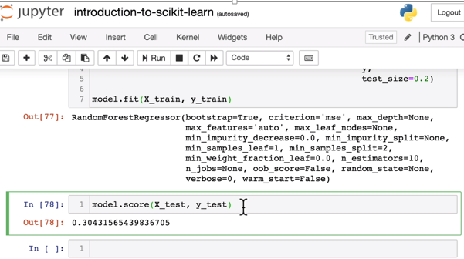

**Missing values:**

car_sales_missing.isna().sum()

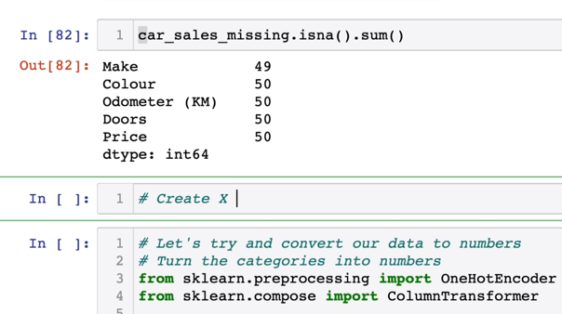

**Option1# filling missing data with pandas**

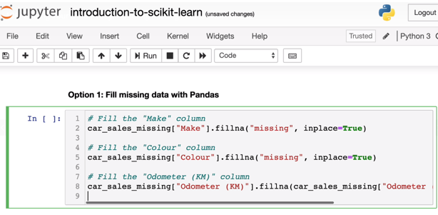

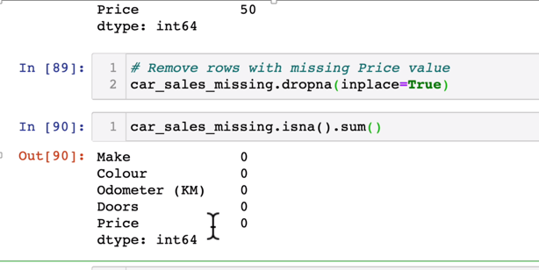

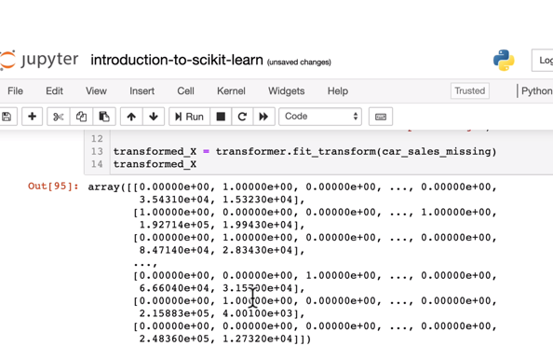

**Filling missing data(nulls) with scikit-learn**

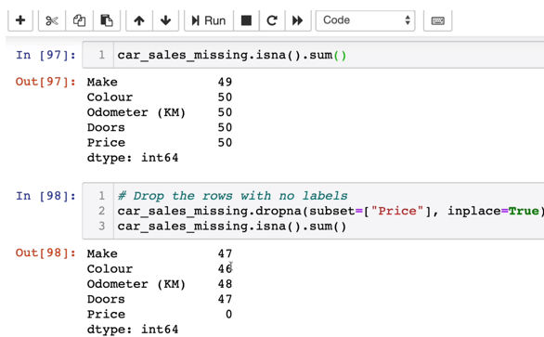

from sklearn.impute import SimpleImputer

from sklearn.compsoe import ColumnTransformer

Below fills the missing values

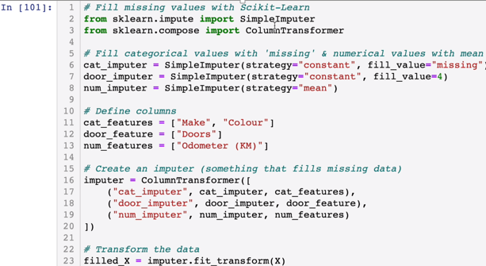

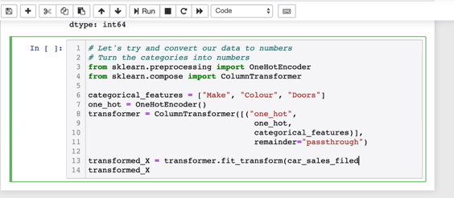

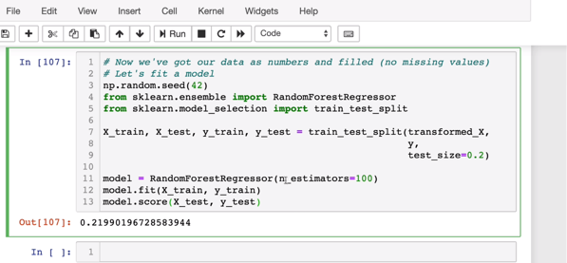

**Choosing the right machine model:**

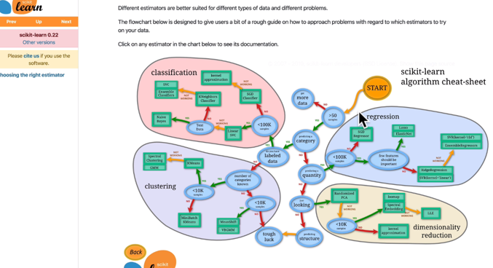

**Now Load data through scikit-learn.**

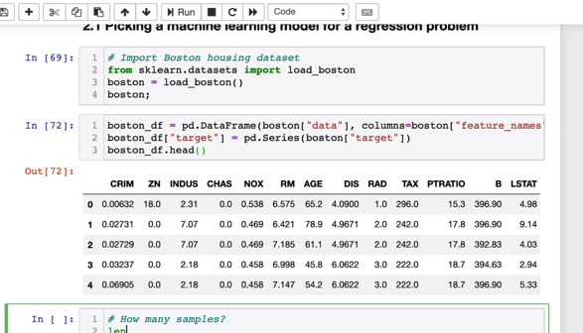

**Ridge _Regression Model:**

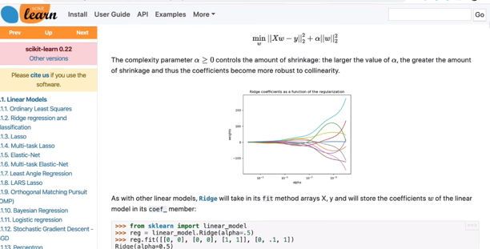

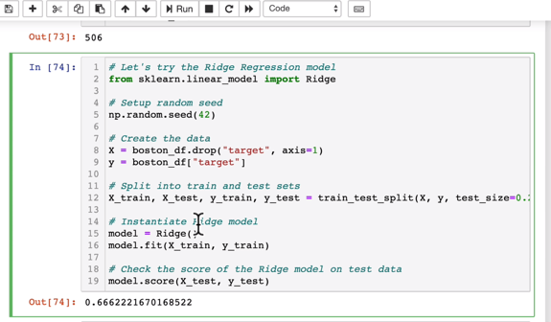

**Ensemble methods model:**

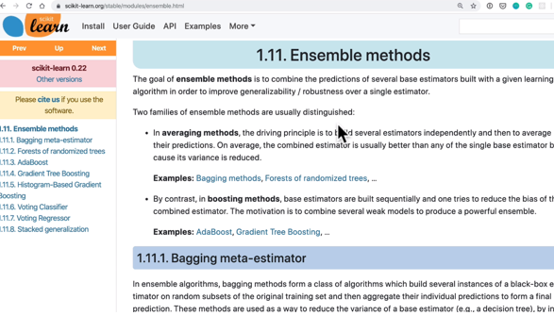

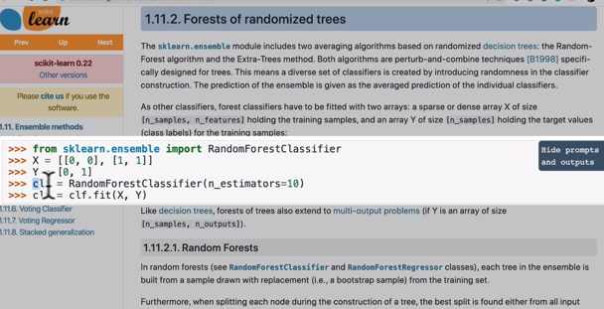

**Random forest regressor:**

**We improved the score by changing the model to regressor model.**

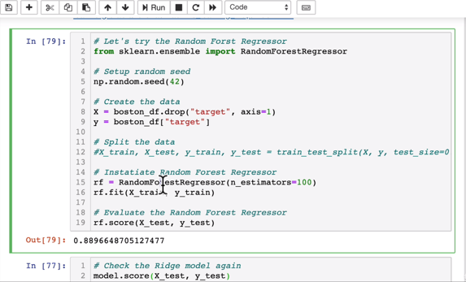

**Decision Tree:**

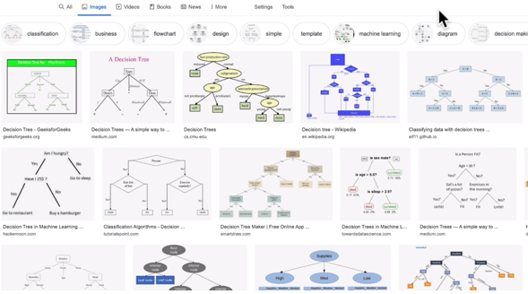

**Classification Machine learning model :**

**Within Classification model should you use ensemble or linear svc model?**

**Linear SVC model:**

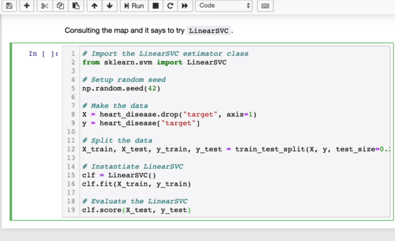

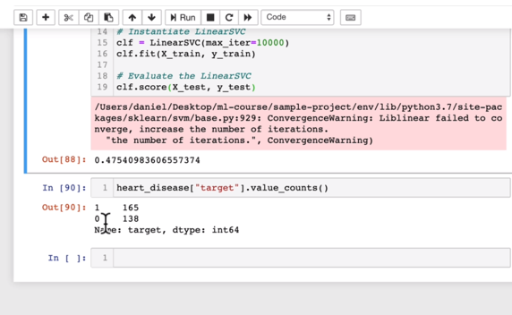

**It is a classic binary classification model and see belwo to count the records**

heart_disease[“target”].value_Counts()

**Since the score is less let’s try ensemble methods**

**Randomforestclassifer model:**

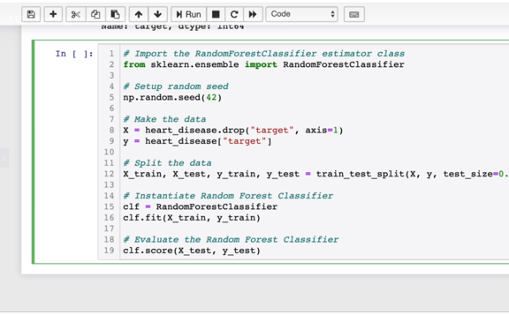

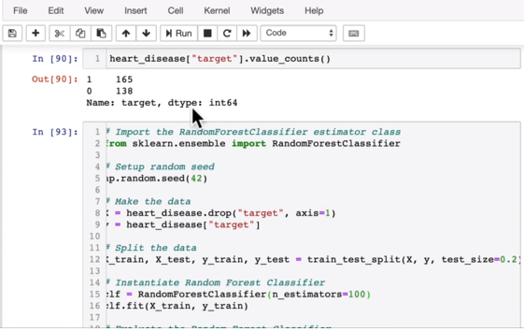

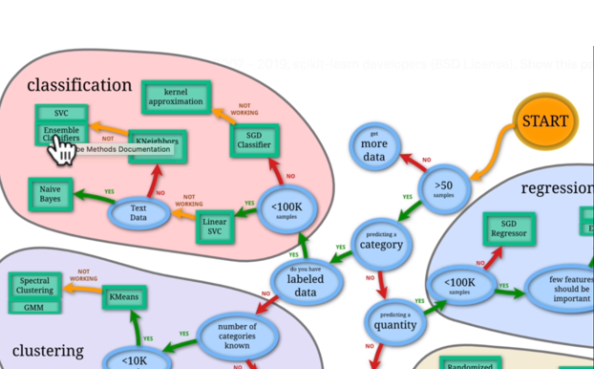

**Note:**

* If you have structured data use ensemble methods
* If you have unstructured data use deep learning or transfer learning

**Make predictions with our model:**

**There are 2 ways to make prediction:**

1. Predict()
2. Predict_proba()

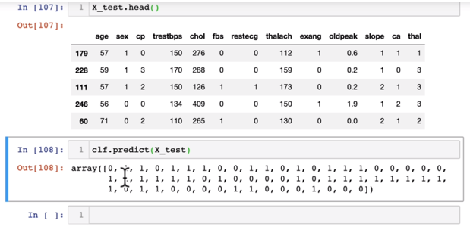

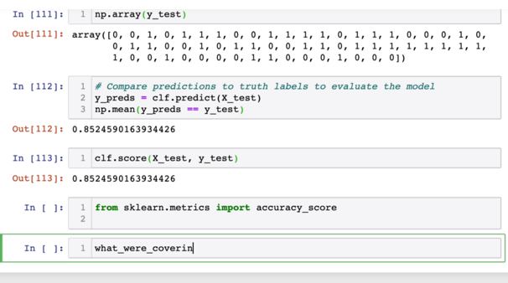

**We are testing the accuracy**

**Using sklearn as well**

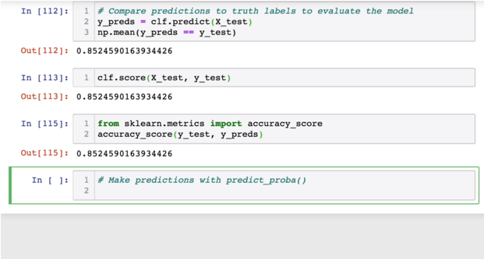

**Predict_proba() function:**

**This returns the probability of the result .**

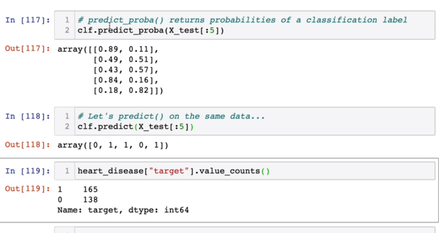

/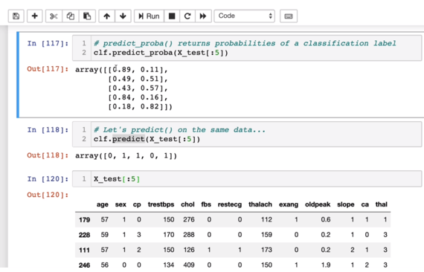

Both of the above are used for predictions for classification model:

**Now how to predict for regression model:**

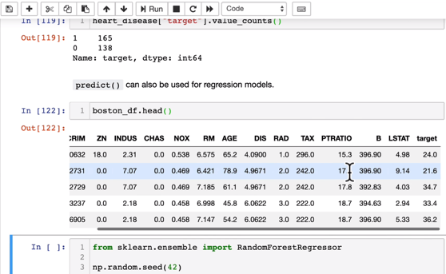

**CODE:**

from sklearn.ensemble import RandomForestRegressor

np.random.seed(42)

#create the data

X = boston_df.drop(“target”, axis = 1)

Y = boston_df[“target”]

**#split the training and testing set**

X_test,X_train,Y_test,Y_train = train_test_split(X,Y,test_size=0.2)

**#Instantiate and fit the model**

model = RandomForestRegressor(n_estimators = 100).fit(X-train,Y_train)

#Make Predictions

Y_preds = model.predict(X_test)

Y_preds[:10] 🡪 This will give us first 10 records

**#Now let’s compare the predictions to the truth**

from sklearn.metrics import mean_absolute_error

mean_absolute_error(Y_test,Y_preds)

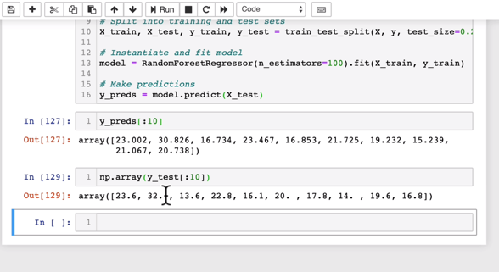

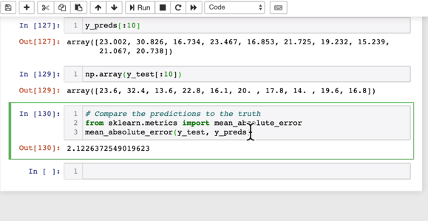

Above the predicted value differs from original Y value by 2.12 on an average

**Now, Let’s evaluate a Model:**

Three ways to evalauate scikit-learn models/estimators

1. **Estimator ‘score’ method**
2. **The ‘scoring’ parameter**
3. **Problem-specific metric functions**

**1.Estimator ‘score’ method**

from sklearn.ensemble import RandomForestClassifier

np.random.seed(42)

X = heart_disease.drop(“Target”, axis = 1)

Y = heart_disease[“target”]

X_train,X_test,Y_train,Y_test = train_test_split(X,Y,test_size = 0.2)

clf = RandomForestClassifier()

clf.fit(X_train,Y_train)

clf.score(X_train,Y_train)

clf.score(X_test,Y_test)

**Let’s do the same for regression:**

from sklearn.ensemble import RandomForestRegressor

np.random.seed(42)

#create the data

X = boston_df.drop(“target”, axis = 1)

Y = boston_df[“target”]

**#split the training and testing set**

X_test,X_train,Y_test,Y_train = train_test_split(X,Y,test_size=0.2)

**#Instantiate and fit the model**

model = RandomForestRegressor(n_estimators = 100).fit(X-train,Y_train)

#Make Predictions

model.score(X_test,Y_test)

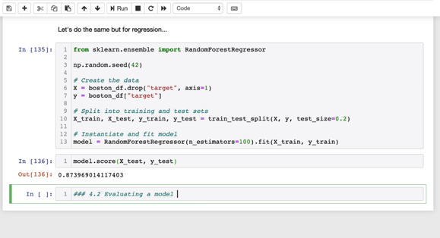

**NOTE:**

Classification model goes by **mean value** and regressor goes by **coefficient determination**

**2. Estimator ‘scoring parameter’ method**

from sklearn.model_selection import cross_val_score

from sklearn.ensemble import RandomForestClassifier

np.random.seed(42)

X = heart_disease.drop(“Target”, axis = 1)

Y = heart_disease[“target”]

X_train,X_test,Y_train,Y_test = train_test_split(X,Y,test_size = 0.2)

clf = RandomForestClassifier(n_estimators = 100)

clf.fit(X_train,Y_train)

clf.score(X_train,Y_train)

cross_val_score(clf,X,Y,cv=5)

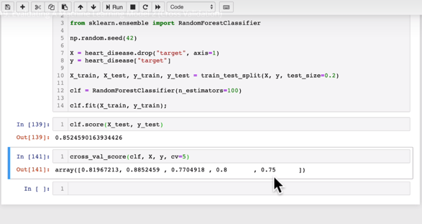

Cross_val_score returns **an array** whereas score returns **a number**

**What is cross_Validation**

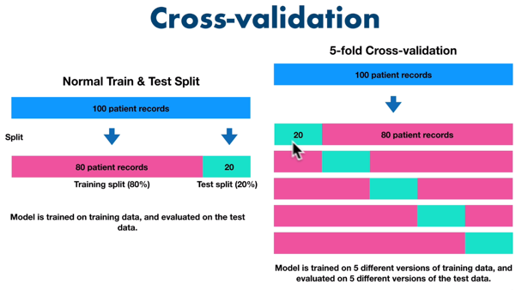

**Scoring parameter is set to None by default:**

**The default parameter will be set to None or of it is None then it will use the default scoring parameter.**

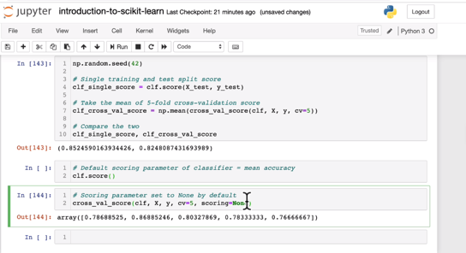

**Classification and Model evaluation metrics:**

1. Accuracy
2. Area under ROC curve
3. Confusion Matrix
4. Classification report
5. Accuracy

Below code will tell us that 8/10 times our model will do the predictions right.

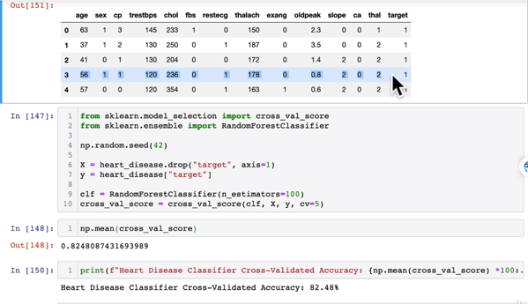

1. Area under ROC curve(AUC / ROC Area under the curve or receiver operating characteristic curve).

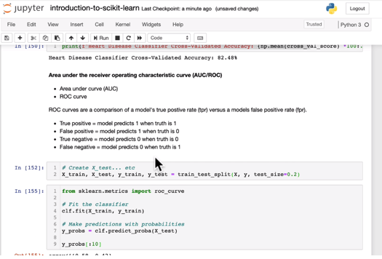

Fpr(false positive rate) and tpr(true positive rate):

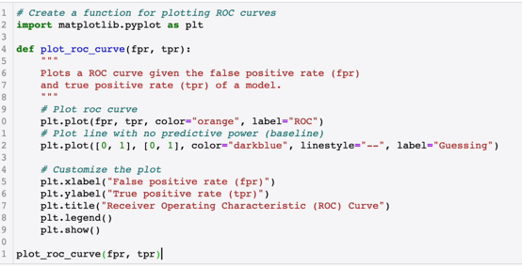

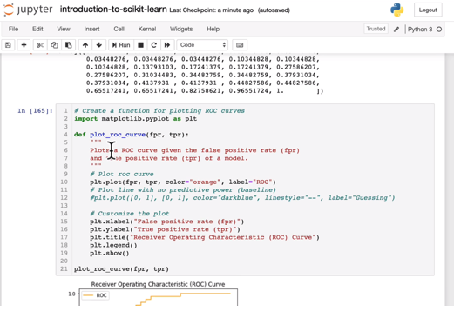

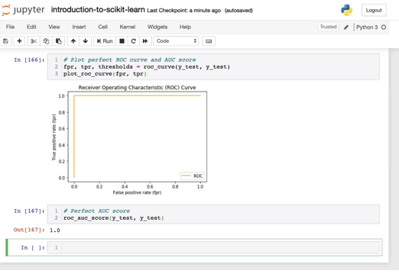

1. **Confusion Matrix:**

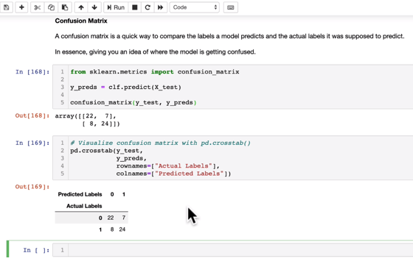

**Confusion matrix anatomy:**

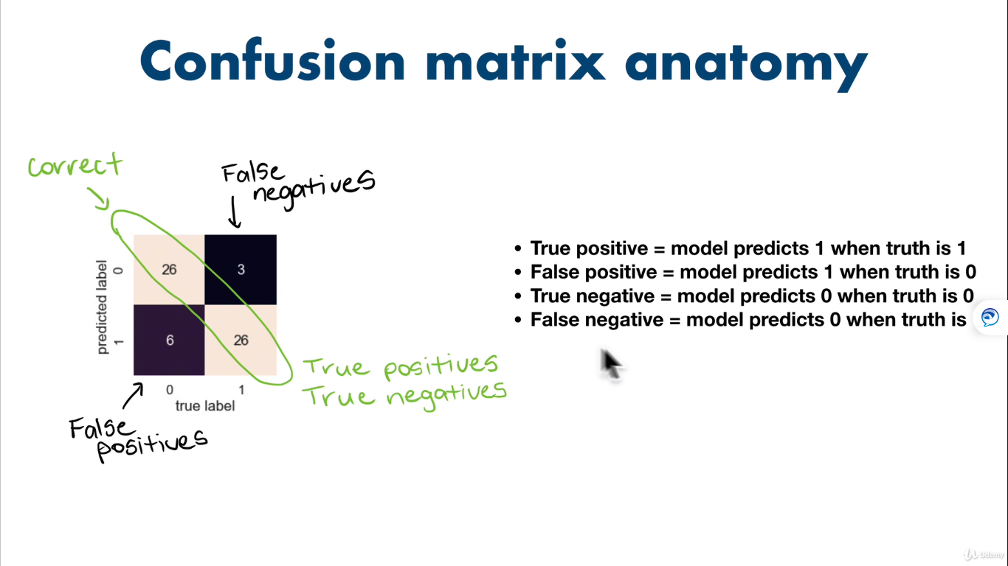

**Seaborn’s heatmap:**

It’s a visualization library built on top of matplotlib

You can install seaborn by below:

Conda install seaborn in the console

Or you can install seaborn with in jupyter notebook

import sys

!conda install –yes –prefix {sys.prefix} seaborn

This should install seaborn

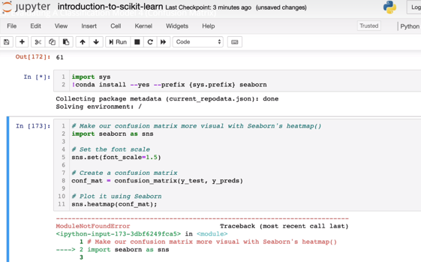

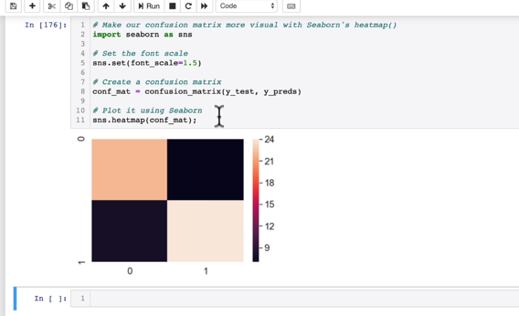

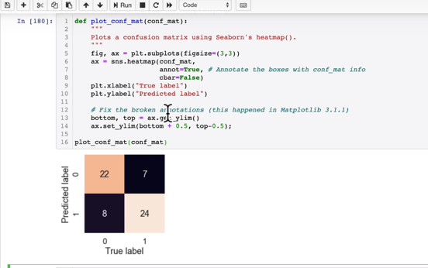

1. **Classification Report:**

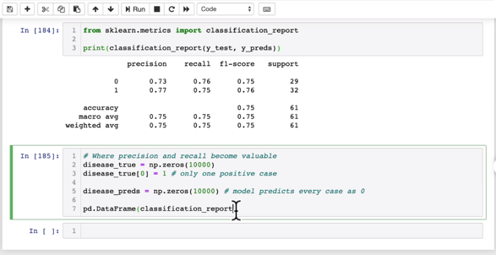

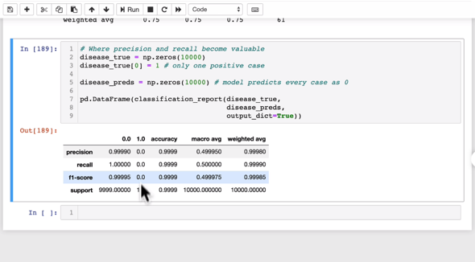

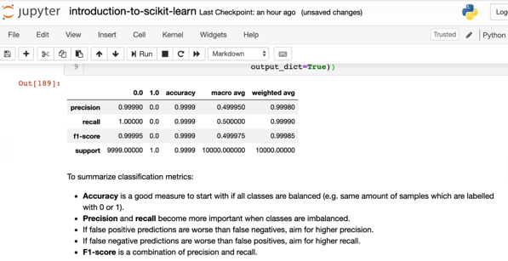

**Regression model evaluation metrics:**

**R2 Score: or R^2 or R squared metrics:**

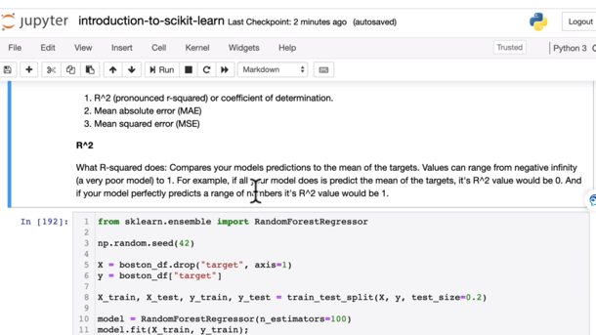

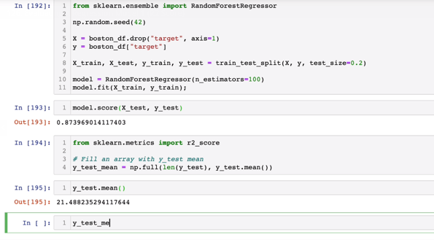

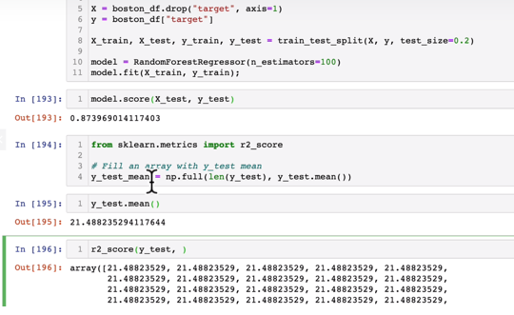

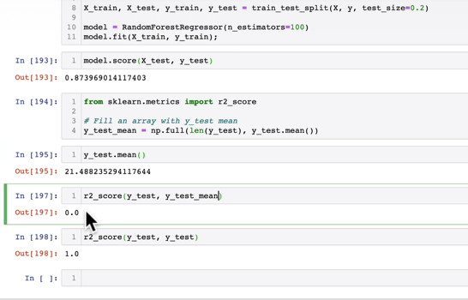

**Mean Absolute Error (MAE):**

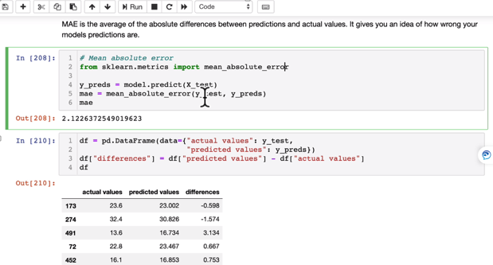

**Mean Squared Error(MSE):**

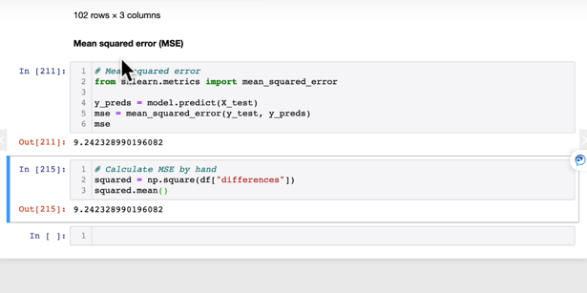

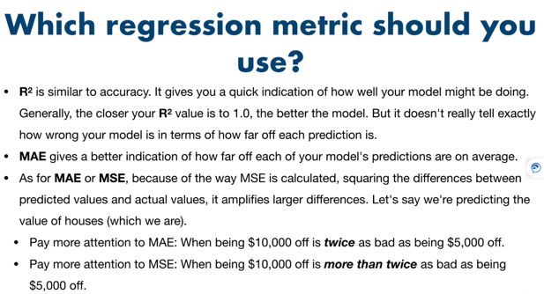

**For a good model metric:**

Minimize mean square error(MSE) and Mean Absolute error (MAE) and maximize R square (R^2)so that it is a good regression metric.

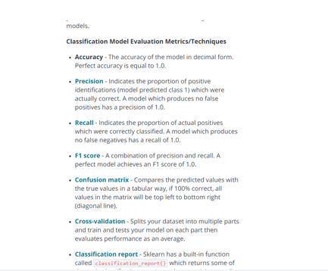

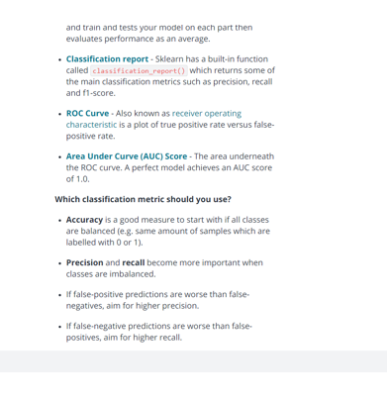

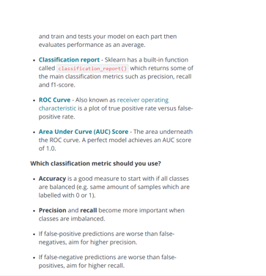

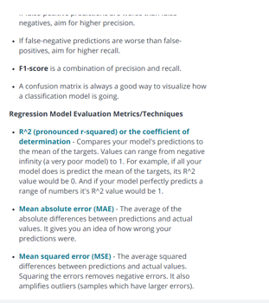

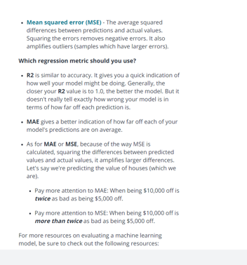

**Cross Validation and Scoring Parameter:**

**For Classificatiobn Model:**

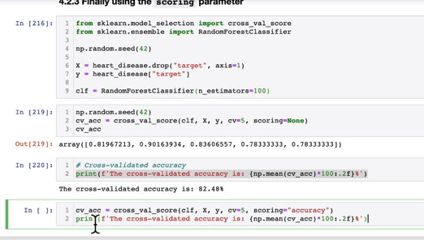

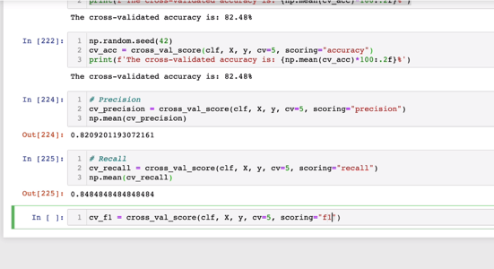

**For Regression Model:**

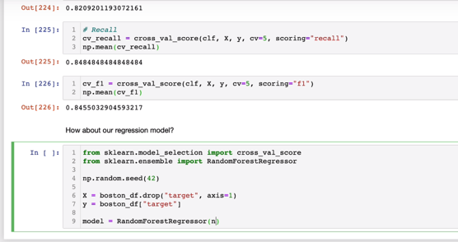

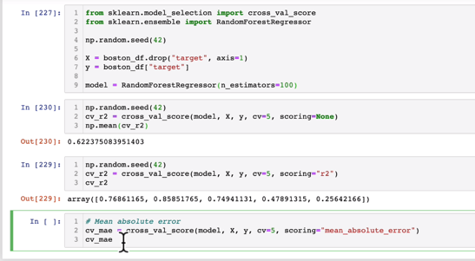

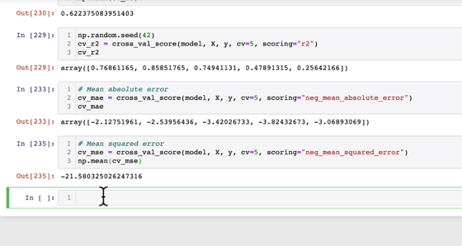

**Scikit-learn functions:**

**Classification Functions:**

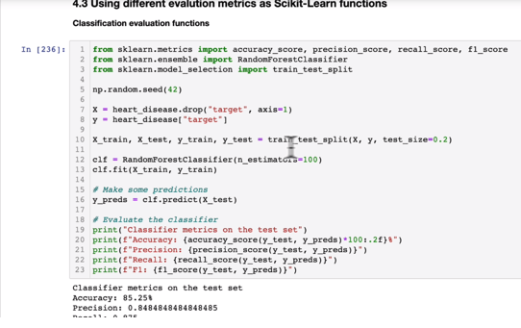

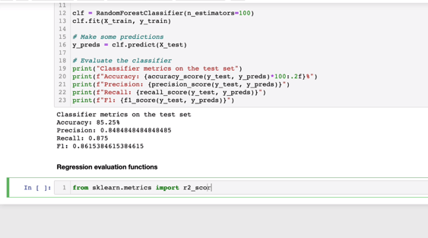

**Regression Functions:**

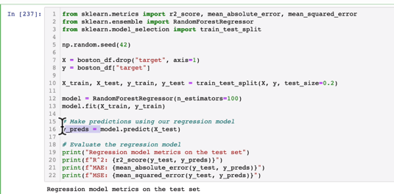

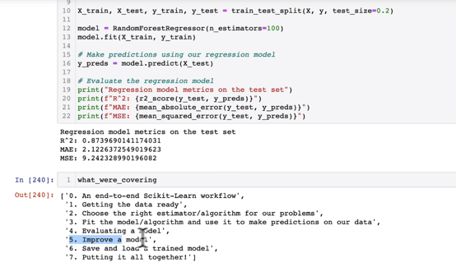

**Improving the model:**

**By adjusting hyperparameters:**

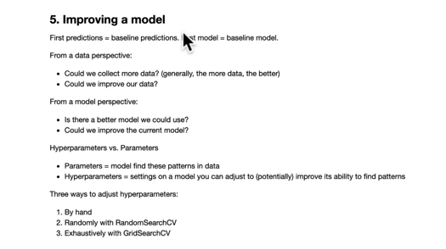

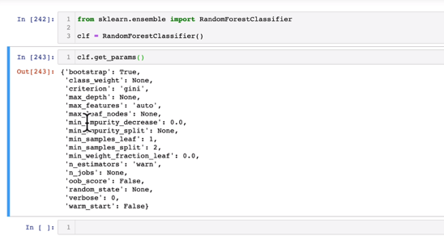

**Tuning hyper-parameters by hand:**

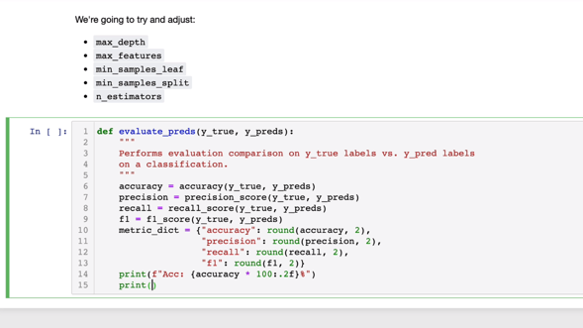

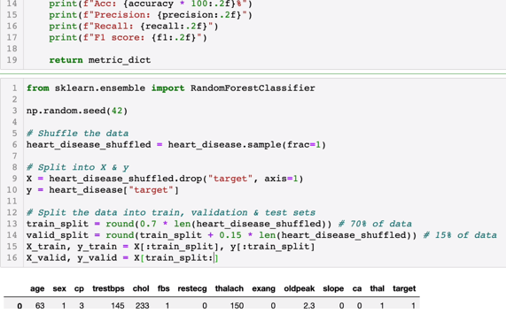

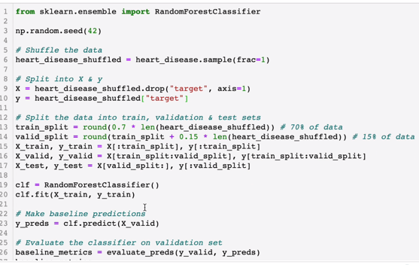

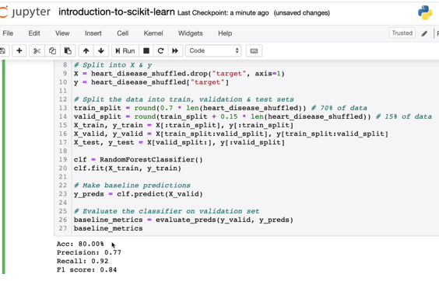

**Now let’s change the hayperparameter n_estimators:**

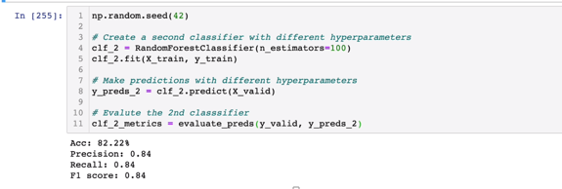

**Tuning with Randomized hyperparamter with RandomizedSearchCV**

This will give the best combination parameters to give us the best results by tuning hyperparamters all by itself.

from sklearn.model_selection import RandomizedSearchCV

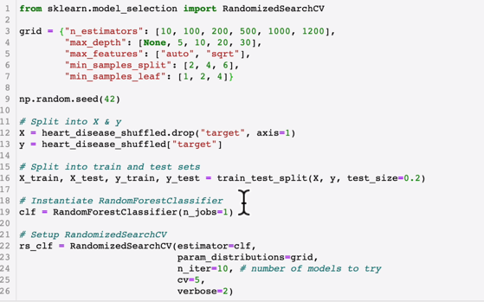

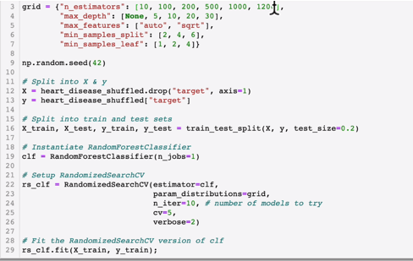

Best parameter combination hyperparameters: This will give yoyu you the best result.

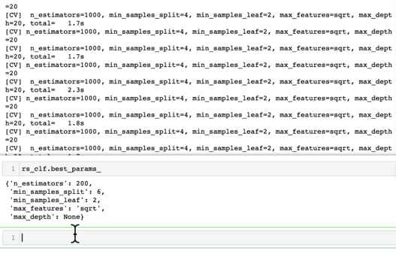

**GritSearchCV:**

It is a brute force search meaning it will go through all combination of parameters given compared to randomized search where we give the search parameter by n_iter =10 meaning it will try to fit only 10 different models.

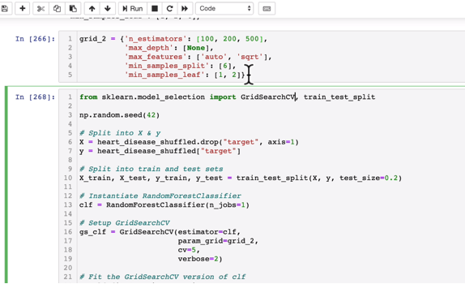

It will go through all the parameters in the grid.

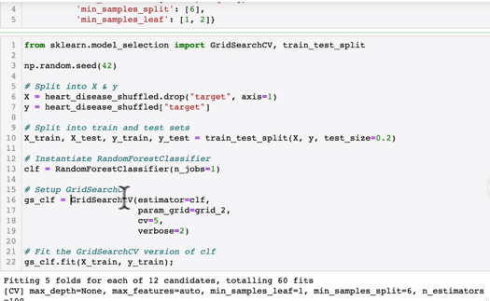

**Now, Best params:**

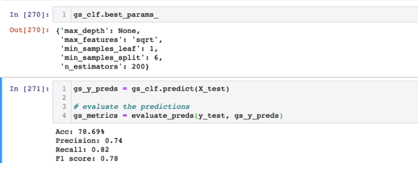

Now lets’ compare the metrics:

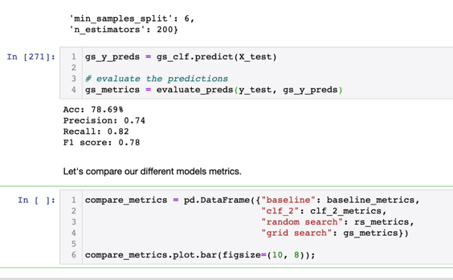

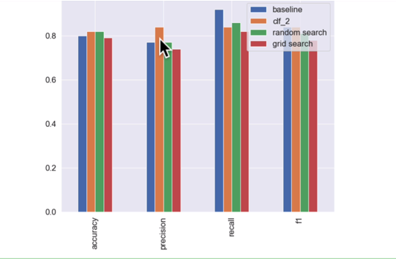

**Correlation_Analysis:**

**Save and Load the model:**

Import pickle

Pickle.dump(gs_clf,open(“file_name.pkl”,”wb”)

Load a saved model:

Loaded_pickle_model = pickle.load(open(“file_name.pkl”,”rb”)

#make some predictions

Pickle_y_preds = loaded_pickle_model.predict(X_test)

Evaluate_preds(Y_test,pickle_Y_preds)

**We can do the same using joblib module:**

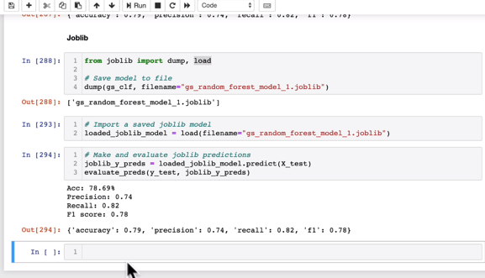

**Final Project**

**To detect car price based on car’s metadata.**

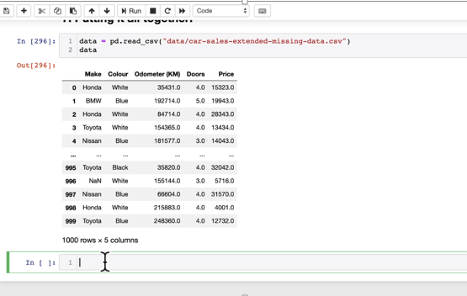

**#Getting Data Ready**

data = pd.read.csv(“car_file.csv”)

data 🡪 TO see the data

data.dtypes 🡪 Make sure all data inputs are numerical

data.isna().sum() 🡪 Make sure there are no nulls

import pandas as pd

import from sklearn.compose import ColumnTransformer

import from sklearn.pipeline import pipeline

import from sklearn.impute import SimpleImputer(This will remove nulls)

import from sklearn.preprocessing import OneHotEncoder(convert data to numbers)

**#now let’s model the data**

from sklearn.ensemble import RandomForestRegressor

from sklearn.model_selection import train_test_split , GridSearchCV

**#setup random seed**

import numpy as np

np.random.seed(42)

**#Import data and drop rows with missing labels**

data = pd.read.csv(“car_file.csv”)

data.dropna(subset=[“price”],inplace=True]

**#Define different features and transformer pipelines**

categorical_features = [“Make”, “Colour”]

categorical_transformer = Pipeline(steps=[

(“imputer”, SimpleImputer(strategy=”constant”, fill_value=”missing”)),

(“onehot”, OneHotEncoder(handle_unknown=”ignore”))])

door_feature = [“Doors”]

door_transformer = Pipeline(steps=[

(“imputer”, SimpleImputer(strategy=”constant”, fill_value=”4))])

numeric_features = [“Odometer (KM)”]

numeric_transformer = Pipeline(steps=[

(“imputer”, SimpleImputer(strategy=”mean”))])

**#setup preprocessing steps(fill miss values, then convert to numbers)**

preprocessor = ColumnTransformer(

transformers=[

(“cat”, categorical_transformer, categorical_features),(cat🡪short form of categorical)

(“door”, doorl_transformer, door_feature),

(“num”, numeric_transformer, numeric_feature)

])

**#creating a preprocessing and modelling pipeline.**

model = Pipeline(steps=[(“preprocessor”,preprocessor),

(“model”, RandomForestRegressor())

]) ( this pipeline is processing in steps of above)

**# Split the Data**

X = data.drop(“price” , axis = 1)

Y = data[“Price”]

X_train,X_test,y_train,y_test = train_test_split(X,y, test_size=0.2)

**# Fit and Score the model**

model.fit(X_train,y_train)

model.score(X_test,y_test)

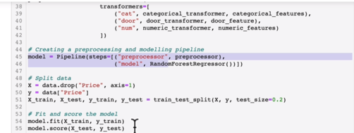

**Now we need to improve the score.**

**It’s also possible to use GridSearchCV or RandomizedCV with our pipeline**

**#use GridsearchCV with our regression pipeline**

from sklearn.model_selection import GridSearchCV

pipe_grid = {

“preprocessor__num__imputer__strategy” : [ “mean”, “median”],

“model__n_estimators” : [100,1000],

“model__max_depth” : [ None,5],

“model__max_features” : [ “auto”],

“model__min_samples_split” : [ 2,4]

}

gs_model = GridSearchCV(model,pipe_grid, cv=5 , verbose=2)

gs_model.fit(X_train,y_train)

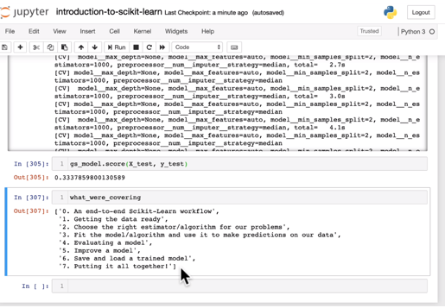

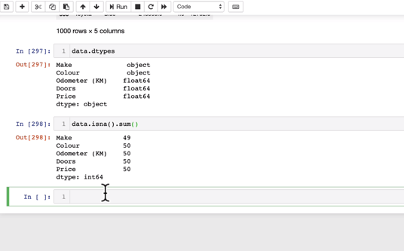

**End to End project on Machine learning:**

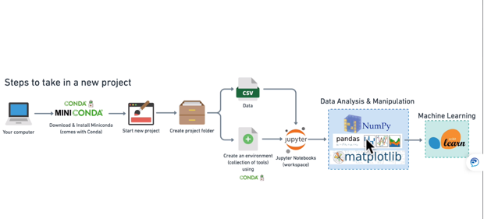

**Lets setup the environment:**

**Lets create new project named “heart-disease-project”**

**In your miniconda prompt:**

Conda env create –prefix ./env pandas matplotlib scikit-learn numpy jupyter

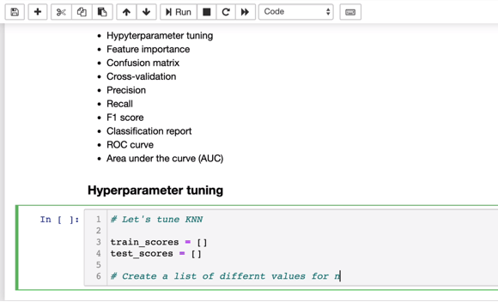

**Convert strings to categories:**

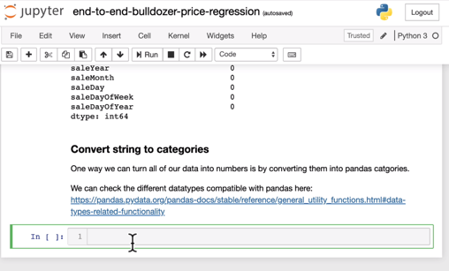

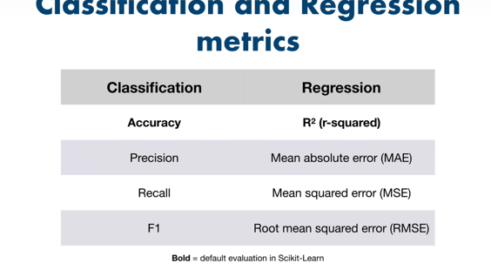

**Data Engineering:**

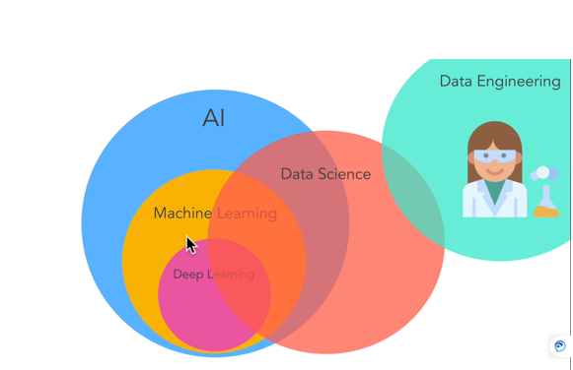

Businesses need to consume these types of data:

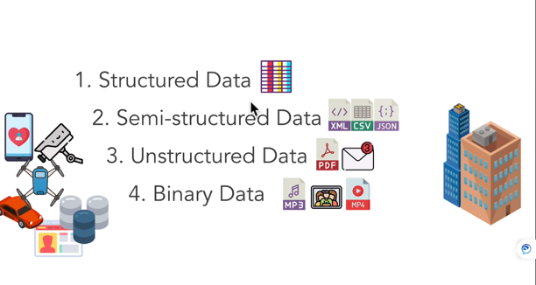

Data Source and Targets:

